University of Arkansas
College of Education
Lesson Plan Format
COE Course

Unit Title: Astronomy | Lesson Title: Measuring Distances in Outer Space
Subject Area: Science | Grade Level: 6th Grade

- Pre-assessment and Planning
Students have had some instruction on solar distance and speed. Formative assessments have indicated a strong need to re-visit the subject. Students have received instruction on the relative positioning of the Earth, moon, and Sun. Students will receive more practice in determining appropriate units for measuring specific distances, as well as learning how to convert units and calculate travel times.

- Objective(s)
ESS.10.6.2 Compare the distance of the following: from the sun to Earth (light minutes), from the next nearest star to Earth (light years)
ESS.10.6.3 Describe how astronomers measure distance to stars.
ESS.10.6.4 Calculate the rate at which we would have to travel to other stars and planets in our solar system using current technology.
*I will compare the distance of the sun to Earth.
*I will compare the distance of the next nearest star to Earth.*I will describe how astronomers measure distance to stars.
*I will calculate the rate at which we would have to travel to other stars and planets in our solar system using current technology.

- Assessment

Name: ___________________
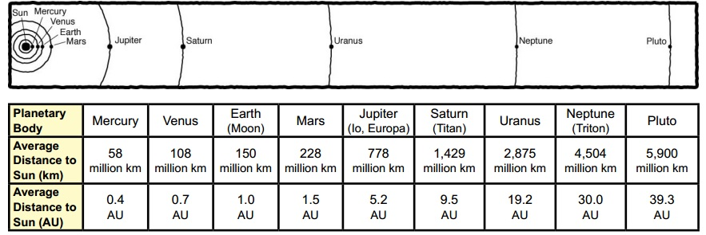

1 light-year = 9.5 x 10¹² km 1 AU = 1.5 x 10⁸ km = 8 light-minutes
1 light-year = 9,500,000,000,000 km 1 AU= 150,000,000 km
1 light second = 300,000 km speed of light = 300,000km/sec
Speed of Voyager Probe= 62,000km/h Distance to Alpha Centauri= 4.2 light years
Walking speed= .0013km/s car speed= .026 km/s Boeing 747= .26km/s
- How long will it take for a person the distance to the Sun from Earth?

- How long would it take for a person to drive the distance to Uranus?

- How long would it take for a person to fly a Boeing 747 to Alpha Centauri?

- Is Saturn closer to Jupiter or Uranus?

- How much longer is a light-minute than a light second?

- How long would it take for a space probe to reach the nearest planet?

Previous Questions:
- How many minutes does it take for light to reach Earth from the surface of the Sun? ______________
- How many light-minutes does it take to reach Pluto? ___________________
- How many times farther is Saturn from the Sun than Earth? _______________
- Is the Earth closer to Venus or Mars?___________________
- Calculate the distance from Earth to Neptune._____________________
- How many years will it take for the Sun’s light to reach Alpha Centauri? _______________
- How many hours will it take for a space probe to reach Jupiter?
- Calculate the speed of light in km/hour.______________________
- Calculate the speed of the a space probe in km/s._______________________
- If the space probe can travel 510,000,000km in one year, how many years will it take to reach Alpha Centauri? [Hint: Find the total number of kilometers from the Sun to Alpha Centuari and divide by the speed of the probe]. _______________________
• Observe groups demonstrating the activity to make sure the concepts are understood. When students are playing the matching card game, they are selecting a distance and a unit that are compatible.
- Describe how you will provide feedback to individual students on their progress toward the objective(s)
  - Student worksheets and science notebooks will be individually assessed and specific feedback will be noted upon their work sources.
- Engaging the Learner
http://www.youtube.com/watch?v=K_xZuopg4Sk
Students will watch the YouTube video to gain a better understanding of the vastness of the universe, parallax, and light years.
- Methods, Activities and Resources
Methods
Whole Group Instruction: Introduction of materials,
Guided Practice: Calculating speeds, distances, and converting units (to be done during presentation when the appropriate charts are visible). Going over the last solar distance and speed handout.
Independent practice- Completing the new solar distances handout
Whole class investigation- playing a matching card game to familiarize students with appropriate units.
Closure
  - Review of lesson referring to the objectives
I will compare the distance of the sun to Earth.
*I will compare the distance of the next nearest star to Earth.
*I will describe how astronomers measure distance to stars.
*I will calculate the rate at which we would have to travel to other stars and planets in our solar system using current technology.
  - Solicit summary of learning from students/feedback to students
    - What went well/what did we learn?
    - What do we need to learn more about?
    - What can we do better next time?
  - Preview of next lesson- Asteroids, meteors, and comets
  - Connect to future learning and real-world experiences

Activities

- Engaging the learner (play videos)- 5 min
- Whole class practice (appropriate distance matching game)- 7 min
- Guided Practice (Reviewing previous solar distance ws.)- 20 min
- Independent practice, completing the new solar distance and speed ws- 20 min
- Conclusion- 3 min
- Transition to next class- 2 min
Resources
- Computer, document camera, overhead projector, Mobius Pad, and Internet
- Resources for classroom use and to extend content knowledge and pedagogy
  - Printed materials- photocopies of the Solar Distances and Speed handout
  - Supplies- tape measurer, weights, 3x5 cards, and tape
  - Audio/video- YouTube video
  - Visuals- Solar system bulletin board
  - Manipulatives- cards for matching game

http://www.youtube.com/watch?v=K_xZuopg4Sk – How big is the universe?

- Potential Adaptations to the Lesson {PAL}
What if:
- Technology fails- refer to printed notes and use the white board to present information
- Material grasped or completed faster or slower than expected- if slower than expected perform more guided practice with changing units. If material is grasped faster than expected proceed to meteors, asteroids, and comets.

- Collaboration
  - This lesson was developed with coordination from my mentor.

