University of Arkansas
College of Education
Lesson Plan Format
COE Course

Unit Title: | Lesson Title:
Subject Area: Science | Grade Level: 6th Grade

- Pre-assessment and Planning
Students have received previous instruction upon plate tectonics, earthquakes, volcanoes, and conducted a webquest on Arkansas land forms. This lesson will make connections between all of these concepts to build an understanding of why the Earth is formed the way it is today. Special focus will be given to landform formation, and the measuring and recording of earthquakes.

Clicker Quiz Pre-assessment
1. The collision of one continental plate with another may produce_________
a. Oceans b. mountains c. plains
2. New ocean crust is formed at a _______________
a. rift-valley b. deep sea trench c. mid-ocean ridge
3. A rift valley can form where two continental plates are ______________
a. moving apart b. moving past one another c. colliding
4. Earthquakes and volcanoes can be measured and somewhat predicted by __________
a. spectrographs b. seismographs c. sonar
The pre-assessment above will provide another way to measure student learning during the lesson and will be compared with student journals after the conclusion of the lesson.

- Objective(s)

*I will explain how volcanic activity relates to mountain formation.
*I will compare and contrast the different landforms caused by Earth's internal forces.
*I will analyze how earthquake occurrences are recorded and measured.

ESS.8.6.6 Explain how volcanic activity relates to mountain formation
ESS.8.6.8 Compare and contrast the different land forms caused by Earth’s internal forces: mountains, plateaus, trenches, islands
ESS.8.6.13 Analyze how earthquake occurrences are recorded (seismograph) and measured (Richter Scale)
Assessment
• Journal Activity: Students will compare and contrast different landforms caused by Earth's internal forces (Mountains, plateaus, rift valleys, mid-ocean ridges, trenches, and islands)
Students will write a short paragraph on how an earthquake is recorded and measured.
Students will complete the theory of plate tectonics handout and turn it in as a 100 point assignment.
Name: _______________________________

 | 5 | 3 | 1
Science Content | Accurate; Connected to big ideas in science | Mostly accurate; Connections to big ideas are not clear | Inaccurate; Not connected to big ideas in science
Organization & Presentation | Main ideas are clearly presented; Ideas are presented in an appropriate order; Ideas are supported by information and logic; Appropriate conclusions are based upon evidence presented; Effective use of models, diagrams, charts, and graphs | Main ideas are presented to some extent; Ideas are not presented in an order that adds clarity; Some ideas are supported by information and logic; Conclusions do not follow from ideas presented; Some appropriate use of models, diagrams, charts, and graphs | No main idea presented; Ideas are presented in an order that distracts from clear communication; Ideas are not supported by information and are illogical; Inappropriate conclusions are presented No use of models, diagrams, charts, and graphs

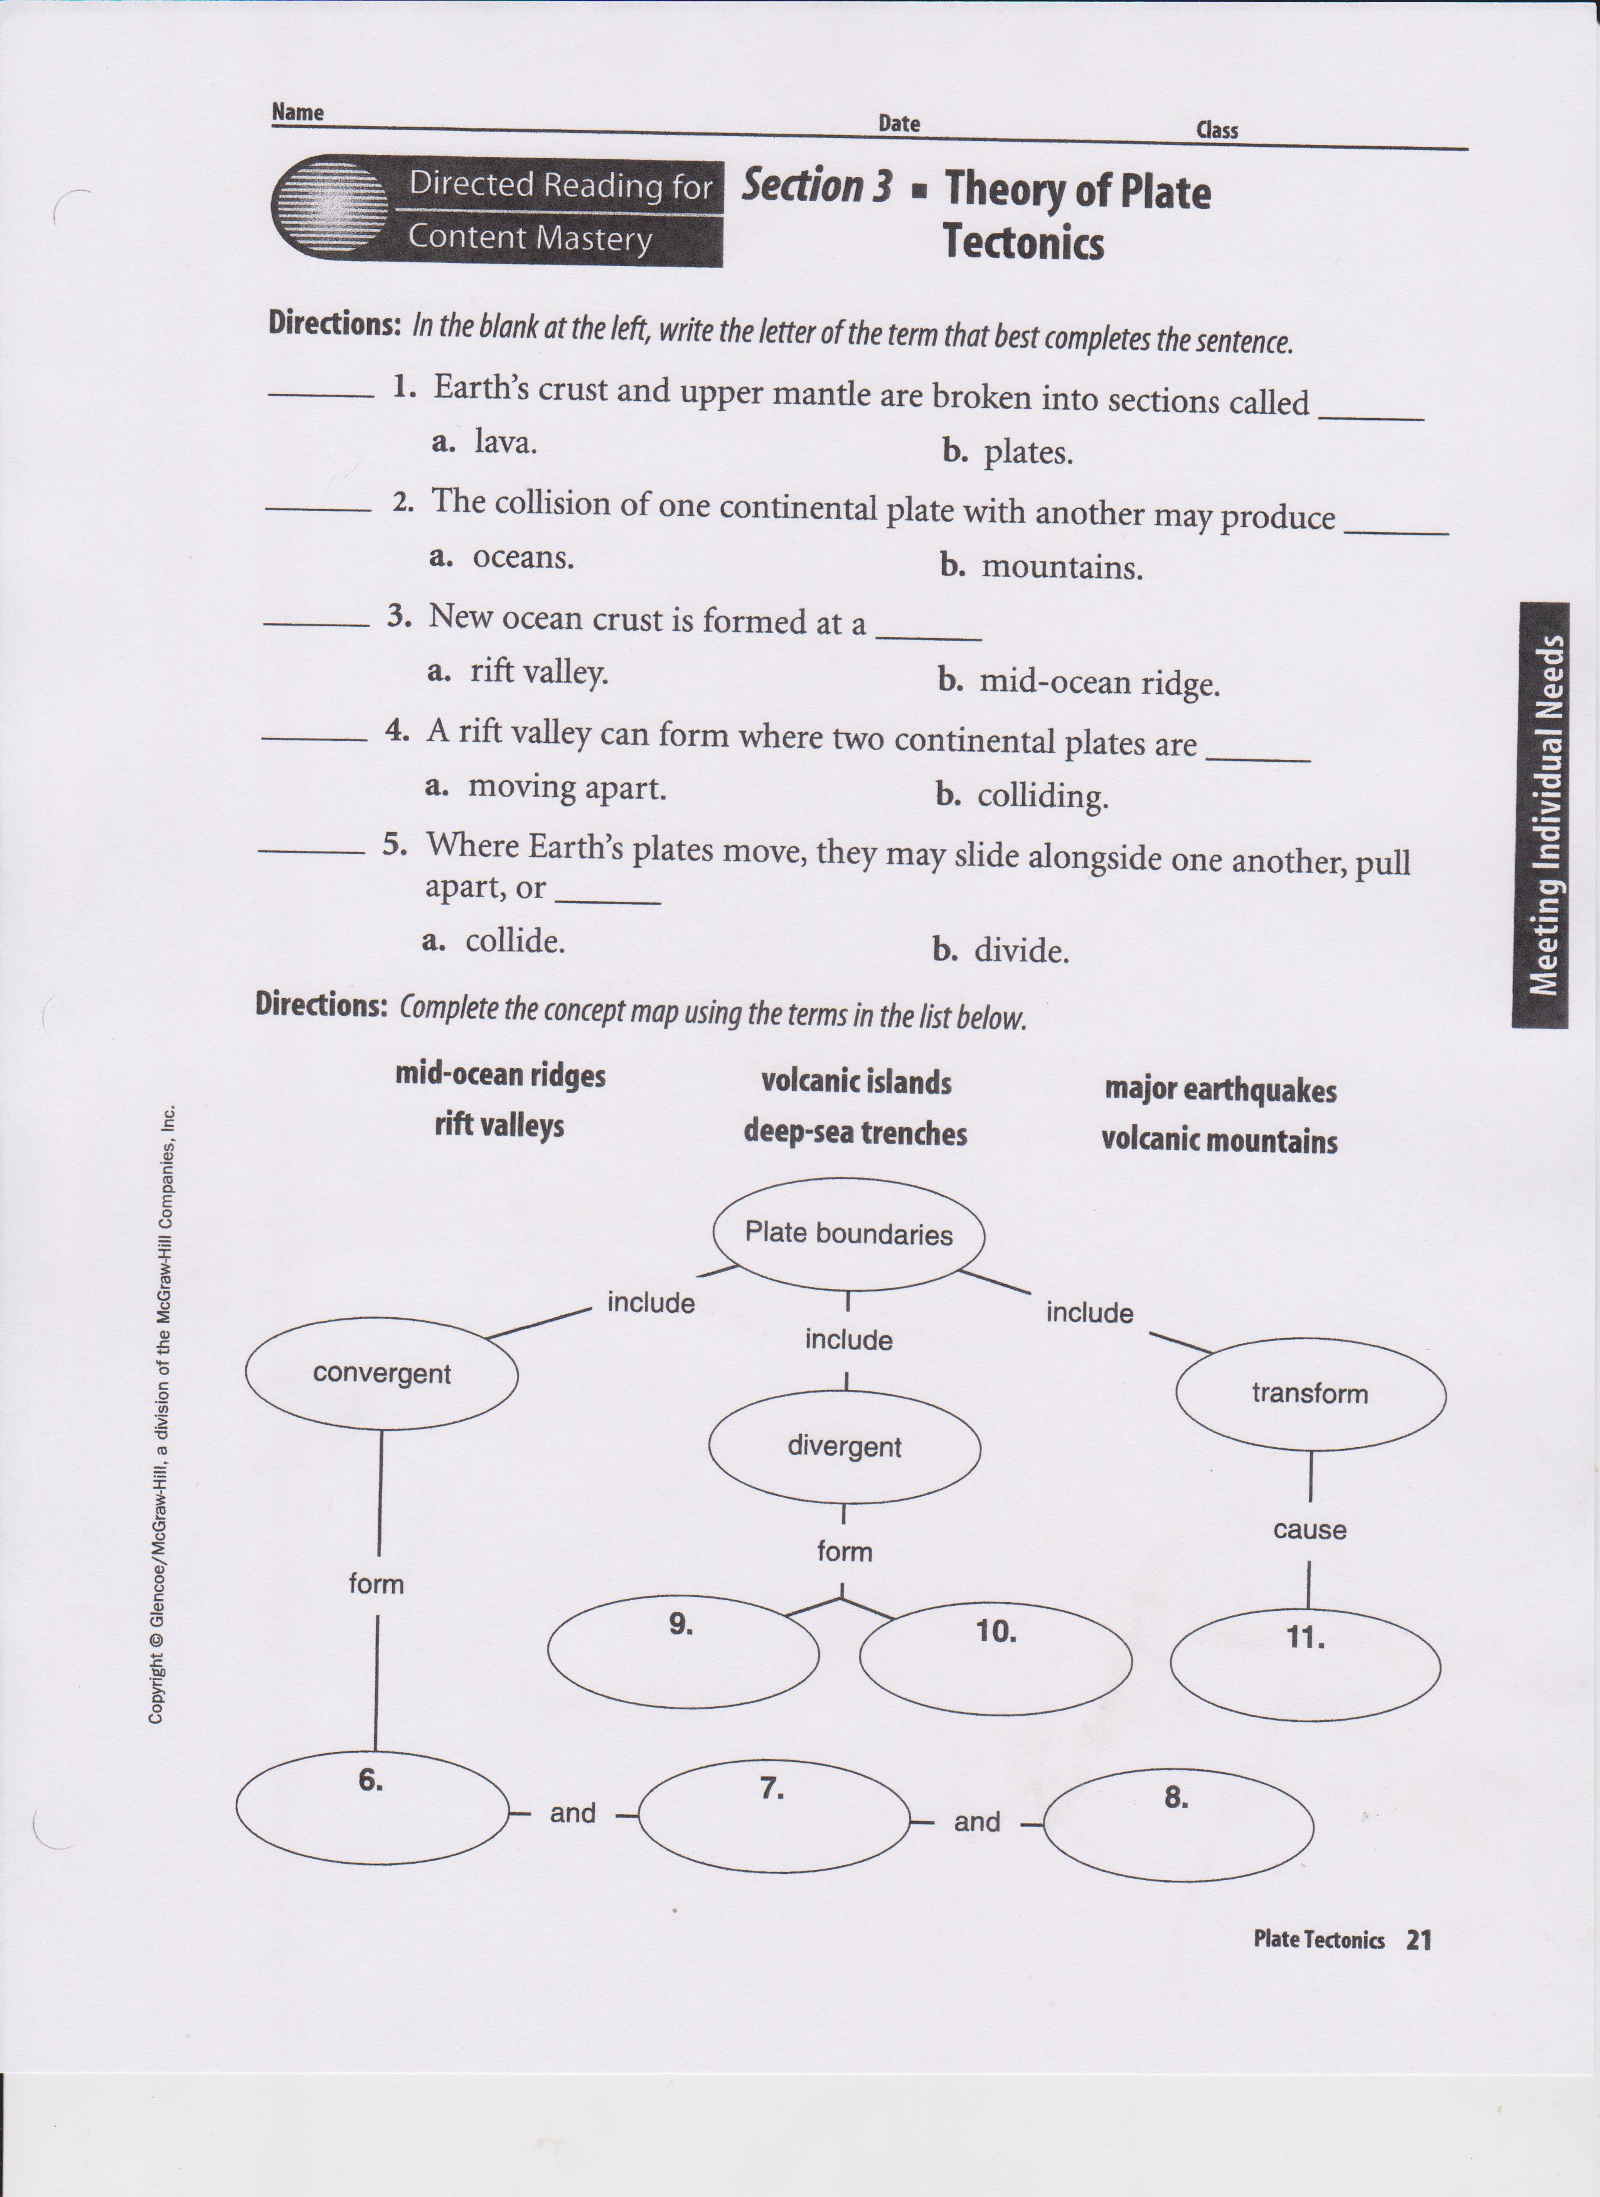

- Engaging the Learner
Students will produce their maps on the movement of plate boundaries. I will then utilize an app to demonstrate a variety of information to students about plate tectonics, earthquakes, volcanoes, and land forms. http://earthguide.ucsd.edu/eoc/teachers/t_tectonics/p_map_plate_layers_bath.html
- Present-day continents are much older geologically than the seafloor of present-day ocean basins. Earliest recognized and dated continental rock (in Australia) was formed about 4.3 billion years ago. In contrast, the geologically oldest seafloor formed about 180 million years ago.
- Why this huge difference in geologic age between continental and oceanic rocks? Answer: the new crust formed along the ocean ridge crests is carried away by plate movement, and is ultimately “recycled” deep into the earth along subduction zones. But because continental crust is thicker and less dense than thinner, younger oceanic, most does not sink deep enough to be recycled and remains largely preserved on land.
Why do different landforms develop?
The constant recycling of the Earth's surface and movement of tectonic plates causes new landforms to be developed before erosion can wear them down.

- Methods, Activities and Resources
Methods
Whole group discussion- engaging the learner (discussing the app), reviewing the web page on different landform formations, recording and measuring earthquakes.
Independent practice- pre-assessment clicker quiz, completing the Theory of Plate Tectonics handout.
Shoulder partner groups- completing science notebook notes.
Closure
  - Review of lesson referring to the objectives
  - Solicit summary of learning from students/feedback to students
  - Preview of next lesson- Moon phases
  - Connect to future learning and real-world experiences- how did the Arkansas landforms develop?

Activities
    - Engaging the learner and making connections (5 min)
    - Clicker quiz (4 min)
    - Reviewing webpage on various plate configurations and drawing diagrams in science notebook (25 min)
    - Play videos on measuring and recording earthquakes, discuss (7 min)
    - Students work on Theory of Plate Tectonics handout (15 min)
    - Extension activity (as time permits)
    - Conclusion (5 min)
Resources
- Computer, overhead projector, document camera, internet access
- Arkansas Science textbooks
- "Plate Boundaries" and "Earthquake and Volcano Mapping" (Previously distributed)
- Theory of Plate Tectonics handout (copied and ready to be distributed)
References
CBS News. (2011). Earthquakes on the pacific "ring of fire". Video retrieved from http://www.youtube.com/watch?v=jpqUu0PLkmM .
American River College (2013). Plate tectonics diagrams. Retrieved from http://web.arc.losrios.edu/~borougt/PlateTectonicsDiagrams.htm
Earthguide. (2011). Maps related to plate tectonics. [Application]. Retrieved from http://earthguide.ucsd.edu/eoc/teachers/t_tectonics/p_map_plate_layers_bath.html
Jones, P. (2011). Bill nye the science guy - Earthquakes (richter scale). Video retrieved from http://www.youtube.com/watch?v=1qbg7orb1lc
Kidsknowit. (2012). How a seismograph works. Video retrieved from http://www.youtube.com/watch?v=Gbd1FcuLJLQ
- Potential Adaptations to the Lesson {PAL}
What if:
- Technology fails- white board diagrams and explanations
- Material grasped or completed faster or slower than expected- if slower, transfer the earthquake objective to next lesson, if faster have students engage in extension activity (identifying landforms on their world maps)

- Collaboration
This lesson plan was developed with collaboration from my mentor teacher.

