University of Arkansas
College of Education
Lesson Plan Format
COE Course

Unit Title: Astronomy | Lesson Title: Moon Phases
Subject Area: Science | Grade Level: 6th

- Pre-assessment and Planning

This lesson is the beginning of a new unit on astronomy standards for 6th grade. Students will take a short pre-assessment quiz on clickers to determine their baseline knowledge of the solar system. The results of the quiz will be evaluated to determine the pacing and order of the unit. Today’s lesson anticipates a common misconception about the causes of the phases of the moon, and it includes an activity to address this misconception.
Students will be grouped in shoulder partner pairs to prevent large disparities in ability for this activity. Student work will be recorded in science notebooks to act as a record of student learning.
“The phases of the moon are caused by the relative position of the Earth, sun, and moon. Most students (and adults) believe that the phases of the moon are caused by the shadow of the Earth on the moon or by the shadows cast on its surface by other objects in the solar system. The real cause of the phases of the moon is its position with respect to the Earth and sun.
What we see of the moon is the light reflected from it. Half of the moon's surface is always in sunlight. We see the moon going through phases because we see varying portions of the sunlit side as the moon revolves around the Earth” (Reed, 2002).

- Objective(s)
I will model moon phases demonstrating the position of Earth, moon and sun

ESS.10.6.7
Model moon phases demonstrating the position of Earth, moon, and sun.

- Assessment
At the end of the two day lesson, I will assess student science journals using the Science Writing Rubric found below to assess their understanding of the phases of the moon .
Check for misconceptions in understanding why the phases occur.
Check for misconceptions in the relative positions of the Earth, moon, and sun.
Name: _______________________________

 | 5 | 3 | 1
Science Content | Accurate; Connected to big ideas in science | Mostly accurate; Connections to big ideas are not clear | Inaccurate; Not connected to big ideas in science
Organization & Presentation | Main ideas are clearly presented; Ideas are presented in an appropriate order; Ideas are supported by information and logic; Appropriate conclusions are based upon evidence presented; Effective use of models, diagrams, charts, and graphs | Main ideas are presented to some extent; Ideas are not presented in an order that adds clarity; Some ideas are supported by information and logic; Conclusions do not follow from ideas presented; Some appropriate use of models, diagrams, charts, and graphs | No main idea presented; Ideas are presented in an order that distracts from clear communication; Ideas are not supported by information and are illogical; Inappropriate conclusions are presented No use of models, diagrams, charts, and graphs

  - Relate observations to the actual phases of the moon.
  - Explain that the moon completes one revolution approximately every 28 days (one month.)
  - Help students describe the changes in the appearance of the moon during a month.
  - Have students identify the predictable pattern of change in the moon's appearance

- Engaging the Learner
Inquiry: What causes the phases of the moon?
(Student name 1) and (Student name 2) were talking about the crescent moon they could see one afternoon. Student 1 said the crescent moon was caused by the shadow of the Earth on the moon. Student 2 said the crescent moon was caused by the relative position of the sun and moon. They agreed the person who was right would get an extra package of Oreos and they went to ask Mr. Bogdon to see who was right.
Ask the class to assume of position in the room dependent upon their answer as a pre-assessment. Instruct the class to sit back down and tell them that in the lesson they will discover the answer and we will model our results in Oreos (using the cream filling to represent the phases of the moon).

- Methods, Activities and Resources
Methods
Whole group discussion – introduction and conclusion
Teacher modeling- beginning of the activity
Shoulder partner group- executing the activity, modeling the phases
Independent practice- completing observations in science journals

Activities
- Pre-assessment quiz for unit (10 min)
- Engaging the learner (5 min)
- Modeling and explaining the activity (5 min)
- Students executing the activity and recording findings (35 min)
- Conclusion and introducing the next lesson (5 min)

Activity:
- Place the light source in the middle of the room. Stand in a large circle around it.
- Give each student a ball.
- Turn out the classroom lights, to make the phases of the moon more visible.
- The light represents the sun. The ball represents the moon. Your head will represent the Earth. Hold the ball in your hand and turn so that the “moon” is between you and the “sun.”
- Slowly turn your body counterclockwise keeping the Earth facing the moon. Notice the edge of the shadow as it moves across the moon.
- Stop once you have completed 1/4 of a revolution and notice the appearance of the moon.
- Continue turning counterclockwise until you have completed 1/2 of a revolution and the sun is behind your head. You will need to raise the moon slightly so that the shadow of your head does not fall on the moon. Notice the appearance of the moon.
- Continue turning counterclockwise until you have completed 3/4 of a revolution. Notice the appearance of the moon.
- Continue turning counterclockwise until you have completed a full revolution. Notice the appearance of the moon.
- Have students repeat the process as many times as needed to gain a clear understanding of the phases of the moon as well as positions of the Earth, moon, and sun during this process.
- Refer students to pg.537 in their science notebooks to identify each phase of the moon.
  - Students will diagram the phases in the science notebook handout and model each phase with oreos (assuming the pacing is going well and classroom management is acceptable, each student pair gets to model the 7 phases).
- Discuss student observations being sure to cover the following.
- Relate observations to the actual phases of the moon.
- Explain that the moon completes one revolution approximately every 28 days (one month.)
- Help students describe the changes in the appearance of the moon during a month
- Have students identify the predictable pattern of change in the moon's appearance.
- Have students summarize their experience in their science journals. They should explain why the appearance of the moon changes in words as well as through illustrations that depict the positions of the Earth, moon, and sun.

Resources
- Computer/Microsoft Office/Internet/overhead camera/projector
- Resources for classroom use and to extend content knowledge and pedagogy
  - 27 styrofoam balls (4”)
  - Bright lamp on center stand
  - Oreo-type cookies
  - Science Notebooks

Use this diagram to model the phases of the moon in this activity. Refer to page 537 to learn the 7 phases of the moon.
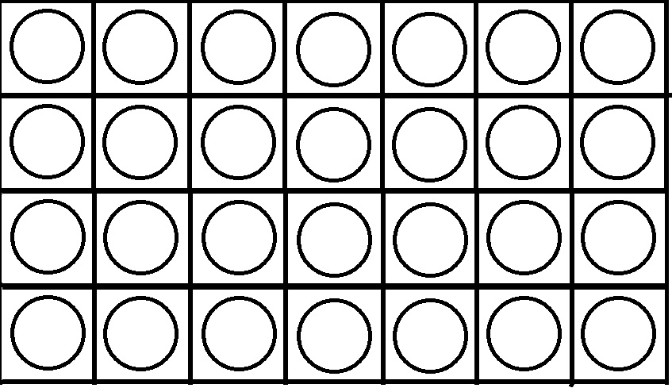
- Potential Adaptations to the Lesson {PAL}
- Technology fails- Utilize the whiteboard to outline the instructions
- Material grasped or completed faster or slower than expected- If slower than expected cut out the modeling with Oreos to prevent distractions. If faster than expected proceed to the lesson on the apparent wandering motions of planets.

- Collaboration
- This lesson was made with coordination from my mentor teacher.

