University of Arkansas
College of Education
Lesson Plan Format
COE Course

Unit Title: | Lesson Title:
Subject Area: | Grade Level:

- Pre-assessment and Planning
A) Bellwork: As the class begins the students will collect their computers from the COW and log into their student accounts. Students will also collect a Webquest handout on the first day. Bellwork will include students executing pre-assigned Mobi-Max tasks on the computers.
Students may be using computers to help kindergarten students log in to a typing program during the 8-8:30 timeframe. Math review problems will be held on hand in case of this event.

- Objective(s)
Objectives: At the conclusion of this lesson, the students should be able to:
1. Construct an interactive timeline relating the creation of Arkansas landforms created by internal forces in within the earth. (Creating)
2. Differentiate the location and formation of geologically significant landmasses within Arkansas (Analyzing)
Frameworks:
ESS.8.6.9
Research local, regional, and state landforms created by internal forces in the earth:
  - Ozark Plateau
  - Crater of Diamonds
  - Ouachita Mountains
  - New Madrid Fault

- Assessment
I will formatively assess the student's progress during the Webquest. I will evaluate the effectiveness of the student's research to determine if they are gaining the information necessary to complete the assignment. If students are experiencing difficulty with the task, I will provide scaffolding to bridge the gaps in knowledge or language.
- At the conclusion of the second day, student outlines and time line progress will be assessed. The completed outlines (the Arkansas Landforms handout) will count as a normal homework grade..
- I will summatively assess the student's timeline and according to the rubric. The timeline will be worth a possible 100 points.
- The student work will be reviewed by peers during the gallery walk and informal peer review will take place.

Category | 4 | 3 | 2 | 1
Content Knowledge | Each of the four landform\'s time and method of creation are accurate. | Three of the four landform\'s time and method of creation are accurate. | Two of the four landform\'s time and method of creation are accurate | One of the four landform\'s time and method of creation are accurate.
Labels | All items of importance on the timeline are clearly labeled with labels that can be read from at least 3 ft. away. | Almost all items of importance on the timeline are clearly labeled with labels that can be read from at least 3 ft. away. | A couple of items of importance on the timeline are clearly labeled with labels that can be read from at least 3 ft. away. | Labels are too small to view OR no important items were labeled.
Creativity | All of the landforms used on the timeline reflect a exceptional degree of creativity in their display. | Two or three of the landforms used on the timeline reflect a degree of creativity in their display. | One of the landforms used on the timeline reflect a creativity in their display. | No creativity in any of the landforms for the timeline.

- Engaging the Learner
I will play a rapid series of slides that shows the movements of the North American Plate from over 500 mya to present day. I will ask the class to explain what theory was demonstrated by the slide show. I will ask leading questions until plate tectonics is mentioned. If the students do not recall tectonic theory I will reinforce the idea that convection currents drive the movement of plates upon the earth's surface. I will use that statement to segue into the four Arkansas landforms created by earth's internal forces.
The bulletin board in the room has pictures of the North American Plate over the last 500 million years arranged in a timeline pattern. Students will be able to reference this timeline as a general model. This extended lesson plan utilizes project-based learning ― an instructional strategy that promotes student engagement because it requires the learner to develop an end product they know will be reviewed by their teacher and peers. The opportunity to create a presentation excites many students, especially when they are able to use the computers to do so.
- Methods, Activities and Resources
Methods
Questioning/Discussion
A) Describe how the activity the students performed relates to the standard. The students developed new ideas about the landforms by utilizing given information to construct a timeline. As the students travel Arkansas they will be more familiar with the landscape's geologic history.
B) Ellicit feedback from the students about the lesson.
C) I will introduce the next lesson, explorations about the solar system.

Explanation of Activity (whole class instruction):
I will use a Prezi to outline the activity and the expectations included in the rubric. I will refer to the graphic organizer which details the order of events the students need to follow in order to complete the assignment. Students will be expected to have the research outline completed by the end of the second day, and their presentations ready halfway through the fourth day. The gallery walk will be on the fourth day during the second part of the class period.
Individual Practice:
Students will navigate the Webquest, conducting research on the four Arkansaslandforms and taking notes on their Webquest handout. Students will then synthesize their research into a presentation for the gallery walk as part of the summative assessment.
Differentiated Instruction:
Students who complete the timeline in advance of the rest of the class will be given an outline of a map of Arkansas and be allowed to construct a 3-D representation ofArkansas's elevation using Play-Doh. I will have a seperate station with the map outlines and Play-Doh near my interactive bulletin board, which has an elevation map for reference.
Conclusion (Whole class discussion)
How did creating the timeline increase your knowledge of Arkansas geography? How do these geologic evens relate to the objectives we covered earlier in this unit? How do these landforms affect our lives today?
Multiple-Intelligences
1) Kinesthetic intelligence- Students will construct an interactive timeline as a manipulative
2) Visual-Spatial- Students will be able to scrutinize the physical arrangement of their timeline to conceptualize the formation of the landforms.
3) Cognitive- Students will apply their research the their timeline and be able to justify which landform they want to visit.
Accommodations:
• GT students will be able to complete the assignment early. I have an alternate assignment prepared for them, the 3-D representations of Arkansas.
• Students who have relevant IEP's allowed extra time to conduct their research and prepare their presentations. Their work may be evaluated after the gallery walk. All students will be encouraged to spend extra time when possible (recess is often held inside due to foul or cold weather) to work on their presentations.
- Google Translate will be available to students who have difficulty reading the English language.
• I will provide a graphic organizer which displays the order of events within the lesson for students who have trouble remember what comes next.
Activities
Explanation: (time)
 | Day 1 | Day 2 | Day 3 | Day 4
Pre Assessment/Anticipatory Set | 10 minutes | 0 | 0 | 0
Explanation of Activity expectations and grading | 10 minutes | 0 | 0 | 0
Individual Practice | 40min | 60 min (evaluate outlines) | 60 min | 20 min
Questioning/Discussion/ Gallery Walk | 0 | 0 | 0 | 40 min

The students will be conducting research on the formation of at least four Arkansas landforms. They will synthesize the research into a presentation that includes a timeline of how each landform was created by internal forces within the earth. They will be given the opportunity to choose the medium for their presentations (electronic or a physical representation).
Resources
A) Overhead projector connected to the computer and document camera- The board will have a series of over 40 concept pictures of the North American Plate over the last 500 million years. The students will place appropriate landform objects within the series of pictures to form a timeline detailing each landform's creation.
B ) Classroom set of computers in the COW.
C) Copies of Webquest outline and .ppt model
D) Pre-made Playdoh
E) Graphic organizer of the order of events
F) Interactive timeline materials (paper, glue, scissors, and colored pencils)
G) Prezi to introduce the webquest http://prezi.com/n6imn1w7xm5s/?utm_campaign=share&utm_medium=copy

Name:_______________
"Where Did Arkansas Get Its Natural Beauty" Webquest Research Handout
Please visit the following URL to find the Webquest and follow the instructions of the Webquest to complete this research handout.
URL: http://questgarden.com/149/55/6/121017195300/process.htm
Complete this handout by conducting research on the websites provided by the Webquest. The handout will act as your outline for your presentation and it is worth a homework grade.
 | Time Period of Creation | Method of Creation and Description
Ozark Plateau
Ouachita Mountains
Crater of Diamonds
New MadridFault
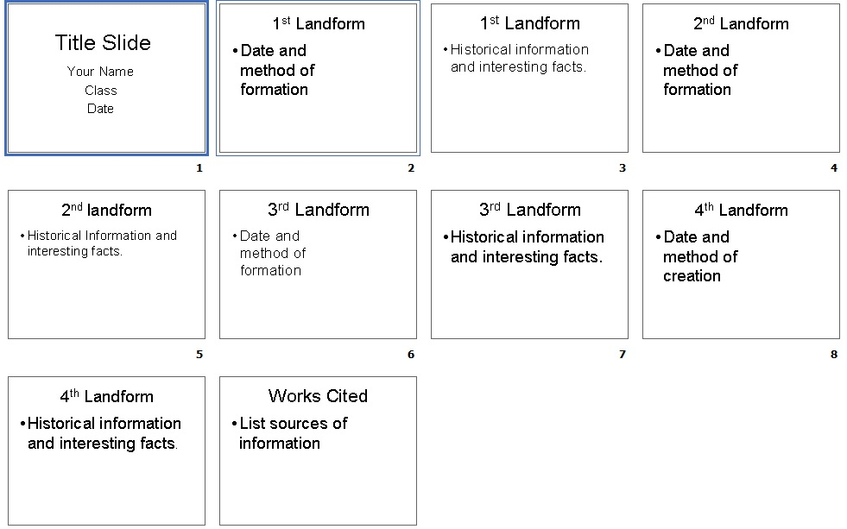
- Potential Adaptations to the Lesson {PAL}
In the event of a technology failure, I will utilize student textbooks to describe the various methods of landform creation that occurred in Arkansas. Each member within the small group will select a landform and take turns within the group describing on the white board how the landform was created. I will summatively assess the student's timelines as seen above.
- Collaboration
- Lesson plan was created with guidance from my mentor teacher.

